

Kauno technologijos universitetas

Informatikos fakultetas

Objektinis programavimas 2 (P175B123)

Laboratorinių darbų ataskaita

Vytenis Kriščiūnas IFF-1/1

Studentas

**doc. dr. Svajūnas Sajavičius**

Dėstytojas

Kaunas 2022

TURINYS

1. Rekursija (L1) 3

1.1. Darbo užduotis 3

1.2. Grafinės vartotojo sąsajos schema 3

1.3. Sąsajoje panaudotų komponentų keičiamos savybės 3

1.4. Klasių diagrama 4

1.5. Programos vartotojo vadovas 4

1.6. Programos tekstas 4

1.7. Pradiniai duomenys ir rezultatai 14

1.8. Dėstytojo pastabos 17

2. Dinaminis atminties valdymas (L2) 18

2.1. Darbo užduotis 18

2.2. Grafinės vartotojo sąsajos schema 18

2.3. Sąsajoje panaudotų komponentų keičiamos savybės 19

2.4. Klasių diagrama 19

2.5. Programos vartotojo vadovas 20

2.6. Programos tekstas 20

2.7. Pradiniai duomenys ir rezultatai 44

2.8. Dėstytojo pastabos 48

# Rekursija (L1)

## Darbo užduotis

LD_10. Kurmiai. Pavasarį sode apsigyveno kurmiai. Kiekvienas kurmis išsirausė sau atskirą urvą. Suskaičiuokite, kiek kurmių apsigyveno sode ir koks yra kiekvieno kurmio išrausto urvo dydis. Duomenys. Faile U3.txt yra pateikta sodo plokštuminė kurmių urvų schema – atvaizduota dvimačiu simbolių masyvu. Pirmoje failo eilutėje yra užrašytas schemos dydis: eilučių skaičius n (5 ≤ n ≤ 500) ir stulpelių skaičius m (5≤ m ≤ 500). Tolesnėse n eilučių yra užrašyta po m simbolių: 'z' (žemė) arba 'u' (urvas). Vienas simbolis atitinka 5 cm2 plotą. Du urvo simboliai ('u') priklauso tam pačiam urvui, jeigu jie yra greta toje pačioje eilutėje arba greta tame pačiame stulpelyje. Rezultatai. Atskirose eilutėse spausdinkite sode apsigyvenusių kurmių skaičių ir kurmių urvų dydžius (cm2 ) surikiuotus mažėjimo tvarka.

## Grafinės vartotojo sąsajos schema

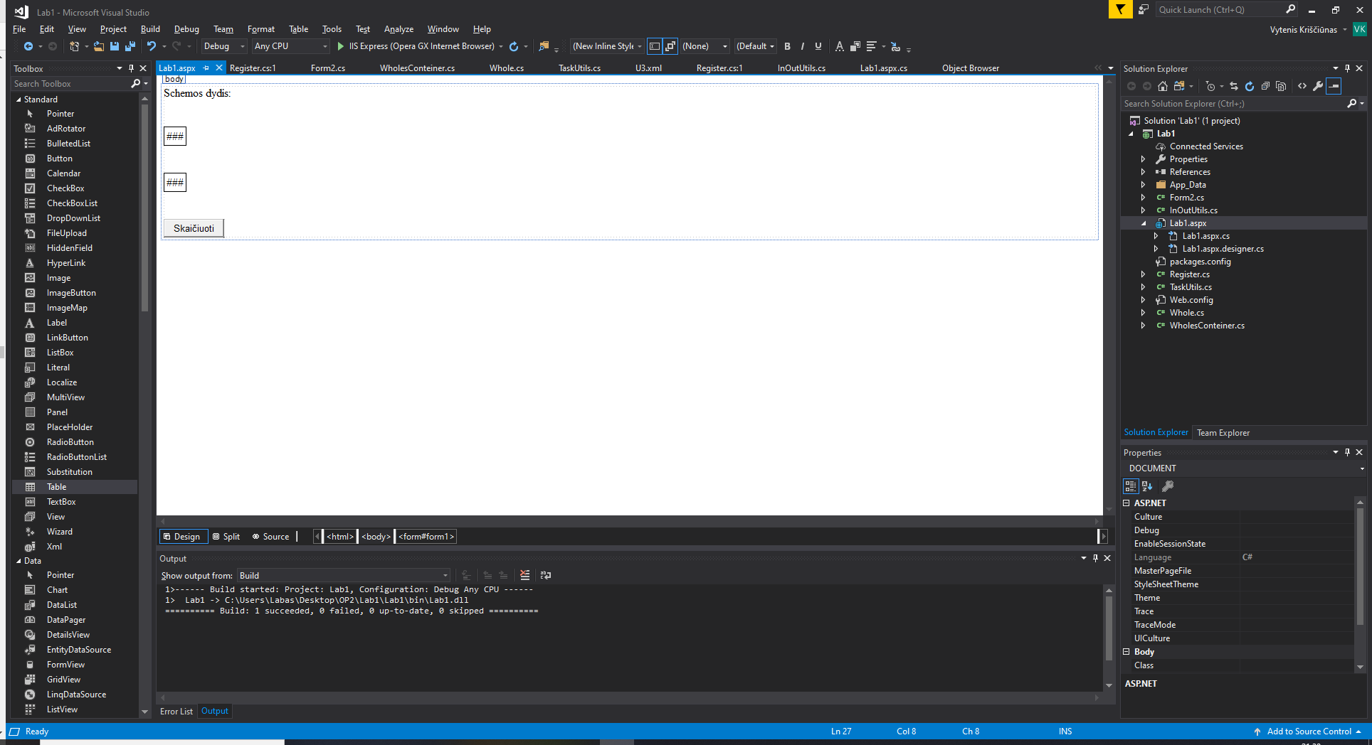

Button1

Table1

Table2

Label1

## Sąsajoje panaudotų komponentų keičiamos savybės

|  |  |  |
| --- | --- | --- |
| Komponentas | Savybė | Reikšmė |
| Button1 | Text | Skaičiuoti |
| Label1 | Text | Schemos dydis: |
| Table1 | BorderColor | Black |
| Table1 | BorderStyle | Solid |
| Table1 | BorderWidth | 1px |
| Table2 | BorderColor | Black |
| Table2 | BorderStyle | Solid |
| Table2 | BorderWidth | 1px |

## Klasių diagrama

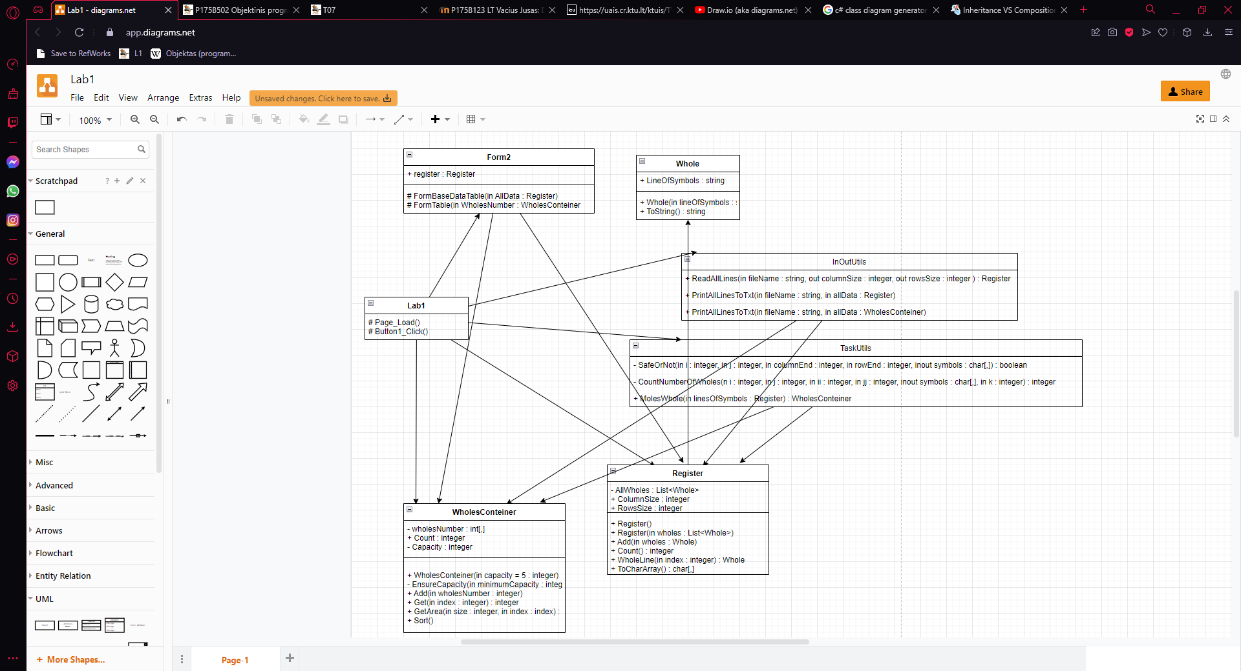

## Programos vartotojo vadovas

Atsidarius puslapiui iškarto galima matyti pirmąjį mygtuką ir pradinius duomenis: schemos dydį ir simbolių lentelę. Paspaudus mygtuką, ant kurio parašyta skaičiuoti atsiranda rezultatų lentelė.

## Programos tekstas

InOutUtils.cs

using System;

using System.Collections.Generic;

using System.Linq;

using System.Web;

using System.IO;

namespace Lab1

{

/// <summary>

/// Class that prints or reads information

/// </summary>

public static class InOutUtils

{

/// <summary>

/// Creates a register of given information

/// </summary>

/// <param name="fileName">Specific file name</param>

/// <param name="columnSize">Information about the columns size</param>

/// <param name="rowsSize">Information about the rows size</param>

/// <returns>Formated list and rows, columns information </returns>

public static Register ReadAllLines(string fileName, out int columnSize, out int rowsSize)

{

Register allWholes = new Register();

string[] allLines = File.ReadAllLines(fileName);

string[] Values = allLines[0].Split(' ');

columnSize = int.Parse(Values[0]);

rowsSize = int.Parse(Values[1]);

for (int i = 0; i < allLines.Count(); i++)

{

if (i > 0)

{

Whole whole = new Whole(allLines[i]);

allWholes.Add(whole);

}

}

return allWholes;

}

/// <summary>

/// Prints information to .txt file

/// </summary>

/// <param name="fileName">Specific file name</param>

/// <param name="allData">Register information</param>

public static void PrintAllLinesToTxt(string fileName, Register allData)

{

string[] lines = new string[allData.Count() + 6];

lines[0] = string.Format(new string('-', 47));

lines[1] = string.Format("| {0,-20} | {1,-20} |", "Eilučių skaičius", "Stulpelių skaičius");

lines[2] = string.Format(new string('-', 47));

lines[3] = string.Format("| {0,20} | {1,20} |", allData.ColumnsSize, allData.RowsSize);

lines[4] = string.Format(new string('-', 47));

for (int i = 0; i < allData.Count(); i++)

{

lines[i + 5] = allData.WholeLine(i).ToString();

}

lines[allData.Count() + 5] = string.Format(new string('-', 24));

File.WriteAllLines(fileName, lines);

}

/// <summary>

/// Prints information to .txt file

/// </summary>

/// <param name="fileName">Specific file name</param>

/// <param name="allData">Conteiner informattion</param>

public static void PrintAllLinesToTxt(string fileName, WholesConteiner allData)

{

string[] lines = new string[allData.Count + 8];

lines[0] = string.Format(new string('-', 24));

lines[1] = string.Format("| {0,-20} |", "Kurmių skaičius");

lines[2] = string.Format(new string('-', 24));

lines[3] = string.Format("| {0,20} |", allData.Count);

lines[4] = string.Format(new string('-', 24));

lines[5] = string.Format("| {0,-20} |", "Kurmių urvų dydžiai");

lines[6] = string.Format(new string('-', 24));

for (int i = 0; i < allData.Count; i++)

{

lines[i + 7] = string.Format("| {0,20} |", allData.GetArea(5, i));

}

lines[allData.Count + 7] = string.Format(new string('-', 24));

File.WriteAllLines(fileName, lines);

}

}

}

Whole.cs

using System;

using System.Collections.Generic;

using System.Linq;

using System.Web;

namespace Lab1

{

/// <summary>

/// Class that gives information about a lines of symbols

/// </summary>

public class Whole

{

/// <summary>

/// String of symbols

/// </summary>

public string LineOfSymbols { get; set; }

/// <summary>

/// Line of symbols constructor

/// </summary>

/// <param name="lineOfSymbols"></param>

public Whole(string lineOfSymbols)

{

this.LineOfSymbols = lineOfSymbols;

}

/// <summary>

/// Overrriden ToString method

/// </summary>

/// <returns>Line of text</returns>

public override string ToString()

{

return string.Format("| {0} |", this.LineOfSymbols);

}

}

}

Register.cs

using System;

using System.Collections.Generic;

using System.Linq;

using System.Web;

namespace Lab1

{

/// <summary>

/// Class that calculates given information

/// </summary>

public class Register

{

/// <summary>

/// List of wholes information

/// </summary>

private List<Whole> AllWholes;

/// <summary>

/// Size of columns

/// </summary>

public int ColumnsSize;

/// <summary>

/// Size of rows

/// </summary>

public int RowsSize;

/// <summary>

/// Formats a list

/// </summary>

public Register()

{

AllWholes = new List<Whole>();

}

/// <summary>

/// Method that disperses information

/// </summary>

/// <param name="wholes">List of members</param>

public Register(List<Whole> wholes)

{

AllWholes = new List<Whole>();

for (int i = 0; i < wholes.Count; i++)

{

AllWholes.Add(wholes[i]);

}

}

/// <summary>

/// Method that adds information to the list

/// </summary>

/// <param name="wholes">Single line of wholes</param>

public void Add(Whole wholes)

{

AllWholes.Add(wholes);

}

/// <summary>

/// Method that counts how many

/// </summary>

/// <returns>Counted rezult</returns>

public int Count()

{

return AllWholes.Count;

}

/// <summary>

/// Method that gives line of information from the list

/// </summary>

/// <param name="index"></param>

/// <returns></returns>

public Whole WholeLine(int index)

{

return AllWholes[index];

}

/// <summary>

/// Method that creates two dimensional char array

/// </summary>

/// <returns>Formated two dimensional char array</returns>

public char[,] ToCharArray()

{

char[,] symbols = new char[ColumnsSize, RowsSize];

for (int i = 0; i < ColumnsSize; i++)

{

for (int j = 0; j < RowsSize; j++)

{

symbols[i, j] = AllWholes[i].LineOfSymbols.ToCharArray()[j];

}

}

return symbols;

}

}

}

TaskUtils.cs

using System;

using System.Collections.Generic;

using System.Linq;

using System.Web;

namespace Lab1

{

/// <summary>

/// A class that does calculations and other tasks

/// </summary>

public static class TaskUtils

{

/// <summary>

/// Method that makes that characters are not out of bound of the array and that there is a searched mole's whole

/// </summary>

/// <param name="i">Column index</param>

/// <param name="j">Row index</param>

/// <param name="columnEnd">Column end index</param>

/// <param name="rowEnd">Row end index</param>

/// <param name="symbols">Array of symbols</param>

/// <returns>True or false</returns>

private static bool SafeOrNot(int i, int j, int columnEnd, int rowEnd, char[,] symbols)

{

if (i < columnEnd && i >= 0 && j < rowEnd && j >= 0 && symbols[i, j] == 'u')

{

return true;

}

else return false;

}

/// <summary>

/// Method that counts the number of mole's created wholes

/// </summary>

/// <param name="i">Column index</param>

/// <param name="j">Row index</param>

/// <param name="ii">Column end index</param>

/// <param name="jj">Row end index</param>

/// <param name="symbols">Array of symbols</param>

/// <param name="k">Integer that is equal to one</param>

/// <returns>Number of wholes</returns>

private static int CountNumberOfWholes(int i, int j, int ii, int jj, char[,] symbols, int k)

{

if (SafeOrNot(i, j, ii, jj, symbols) == true)

{

symbols[i, j] = 'z';

return k + CountNumberOfWholes(i, j + 1, ii, jj, symbols, k) + CountNumberOfWholes(i, j - 1, ii, jj, symbols, k) + CountNumberOfWholes(i + 1, j, ii, jj, symbols, k) + CountNumberOfWholes(i - 1, j, ii, jj, symbols, k);

}

return 0;

}

/// <summary>

/// Method that creates a conteiner of found information about the moles

/// </summary>

/// <param name="linesOfSymbols">Register information</param>

/// <returns>Moles Conteiner</returns>

public static WholesConteiner MolesWholes(Register linesOfSymbols)

{

WholesConteiner molesWholes = new WholesConteiner();

char[,] symbols = linesOfSymbols.ToCharArray();

for (int i = 0; i < linesOfSymbols.ColumnsSize; i++)

{

for (int j = 0; j < linesOfSymbols.RowsSize; j++)

{

int numberOfWholes = CountNumberOfWholes(i, j, linesOfSymbols.ColumnsSize, linesOfSymbols.RowsSize, symbols, 1);

if (numberOfWholes != 0)

{

molesWholes.Add(numberOfWholes);

}

}

}

return molesWholes;

}

}

}

WholesConteiner.cs

using System;

using System.Collections.Generic;

using System.Linq;

using System.Web;

namespace Lab1

{

/// <summary>

/// Conteiner of counted wholes

/// </summary>

public class WholesConteiner

{

/// <summary>

/// Array of wholes

/// </summary>

private int[] wholesNumber;

/// <summary>

/// Count of moles

/// </summary>

public int Count { get; private set; }

/// <summary>

/// Total capacity of moles

/// </summary>

private int Capacity;

/// <summary>

/// WholesConteiner constructor

/// </summary>

/// <param name="capacity">Capacity of moles</param>

public WholesConteiner(int capacity = 5)

{

this.Capacity = capacity;

this.wholesNumber = new int[capacity];

}

/// <summary>

/// Method that makes sure of the moles capacity

/// </summary>

/// <param name="minimumCapacity">Minimum capacity of moles</param>

private void EnsureCapacity(int minimumCapacity)

{

if (minimumCapacity > this.Capacity)

{

int[] temp = new int[minimumCapacity];

for (int i = 0; i < this.Count; i++)

{

temp[i] = wholesNumber[i];

}

this.Capacity = minimumCapacity;

wholesNumber = temp;

}

}

/// <summary>

/// Method that adds wholes number to the array

/// </summary>

/// <param name="wholesNumber">Wholes number</param>

public void Add(int wholesNumber)

{

if (Capacity == Count)

{

EnsureCapacity(Capacity * 2);

}

this.wholesNumber[Count++] = wholesNumber;

}

/// <summary>

/// Method that gives information about mole's number of created wholes

/// </summary>

/// <param name="index">Index of a single mole</param>

/// <returns>Number of wholes</returns>

public int Get(int index)

{

return wholesNumber[index];

}

/// <summary>

/// Method that calculates and gives information about the size of wholes

/// </summary>

/// <param name="size">Size of one whole</param>

/// <param name="index">Index of a single mole</param>

/// <returns>Claculated area informationn</returns>

public int GetArea(int size, int index)

{

return wholesNumber[index] * size;

}

/// <summary>

/// Method that sorts information the conteiner

/// </summary>

public void Sort()

{

for (int i = 0; i < wholesNumber.Count(); i++)

{

for (int j = i + 1; j < wholesNumber.Count(); j++)

{

if (wholesNumber[i] < wholesNumber[j])

{

int a = wholesNumber[i];

int b = wholesNumber[j];

wholesNumber[i] = b;

wholesNumber[j] = a;

}

}

}

}

}

}

Forma2.cs

using System;

using System.Collections.Generic;

using System.Linq;

using System.Web;

using System.Web.UI;

using System.Web.UI.WebControls;

using System.IO;

namespace Lab1

{

/// <summary>

/// Web form extention

/// </summary>

public partial class Lab1 : System.Web.UI.Page

{

/// <summary>

/// Register for given data

/// </summary>

Register register;

/// <summary>

/// Method that forms a Table to the screen

/// </summary>

/// <param name="AllData">Register of base data</param>

protected void FormBaseDataTable(Register AllData)

{

TableRow row1 = new TableRow();

TableCell item1 = new TableCell();

item1.Text = "<b>Simboliai</b>";

row1.Cells.Add(item1);

Table2.Rows.Add(row1);

for (int i = 0; i < AllData.Count(); i++)

{

TableRow row2 = new TableRow();

TableCell item2 = new TableCell();

item2.Text = AllData.WholeLine(i).LineOfSymbols;

row2.Cells.Add(item2);

Table2.Rows.Add(row2);

}

}

/// <summary>

/// Method that forms a Table to the screen

/// </summary>

/// <param name="WholesNumber">Conteiner of rezults</param>

protected void FormTable(WholesConteiner WholesNumber)

{

TableRow row1 = new TableRow();

TableCell item1 = new TableCell();

item1.Text = string.Format("Kurmių skaičius: {0}", WholesNumber.Count);

row1.Cells.Add(item1);

Table1.Rows.Add(row1);

for (int i = 0; i < WholesNumber.Count; i++)

{

TableRow row2 = new TableRow();

TableCell item2 = new TableCell();

item2.Text = string.Format("{0}", WholesNumber.GetArea(5, i));

row2.Cells.Add(item2);

Table1.Rows.Add(row2);

}

}

}

}

Lab1.aspx

<%@ Page Language="C#" AutoEventWireup="true" CodeBehind="Lab1.aspx.cs" Inherits="Lab1.Lab1" %>

<!DOCTYPE html>

<html xmlns="http://www.w3.org/1999/xhtml">

<head runat="server">

<title></title>

</head>

<body>

<form id="form1" runat="server">

<div>

<asp:Label ID="Label1" runat="server" Text="Schemos dydis: "></asp:Label>

<br />

<br />

<asp:Table ID="Table2" runat="server" BorderColor="Black" BorderStyle="Solid" BorderWidth="1px">

</asp:Table>

<br />

<br />

<asp:Table ID="Table1" runat="server" BorderColor="Black" BorderStyle="Solid" BorderWidth="1px">

</asp:Table>

<br />

<br />

<asp:Button ID="Button1" runat="server" OnClick="Button1_Click" Text="Skaičiuoti" />

</div>

</form>

</body>

</html>

Lab1.apsx.cs

using System;

using System.Collections.Generic;

using System.Linq;

using System.Web;

using System.Web.UI;

using System.Web.UI.WebControls;

using System.IO;

//Main function of this program is to find the number of moles and their created wholes numbers

//Vytenis Kriščiūnas

namespace Lab1

{

/// <summary>

/// Web form

/// </summary>

public partial class Lab1 : System.Web.UI.Page

{

/// <summary>

/// Prints information to the screen when page loads

/// </summary>

/// <param name="sender">An object variable</param>

/// <param name="e">EventArgs variable</param>

protected void Page_Load(object sender, EventArgs e)

{

if (register == null)

{

register = new Register();

}

int columnSize, rowsSize;

register = InOutUtils.ReadAllLines(Server.MapPath("App_Data/U3.txt"), out columnSize, out rowsSize);

register.ColumnsSize = columnSize;

register.RowsSize = rowsSize;

InOutUtils.PrintAllLinesToTxt(Server.MapPath("GigvenData.txt"), register);

Label1.Text = "Schemos dydis: " + register.ColumnsSize + " " + register.RowsSize;

FormBaseDataTable(register);

}

/// <summary>

/// Prints information to the screen when first button is clicked

/// </summary>

/// <param name="sender">An object variable</param>

/// <param name="e">EventArgs variable</param>

protected void Button1_Click(object sender, EventArgs e)

{

WholesConteiner countedWholes = TaskUtils.MolesWholes(register);

countedWholes.Sort();

TableRow row = new TableRow();

TableCell item = new TableCell();

item.Text = "<b>Rezultatai</b>";

row.Cells.Add(item);

Table1.Rows.Add(row);

FormTable(countedWholes);

InOutUtils.PrintAllLinesToTxt(Server.MapPath("Rezults.txt"), countedWholes);

}

}

}

Lab1.apsx.designer.cs

//------------------------------------------------------------------------------

// <auto-generated>

// This code was generated by a tool.

//

// Changes to this file may cause incorrect behavior and will be lost if

// the code is regenerated.

// </auto-generated>

//------------------------------------------------------------------------------

namespace Lab1 {

public partial class Lab1 {

/// <summary>

/// form1 control.

/// </summary>

/// <remarks>

/// Auto-generated field.

/// To modify move field declaration from designer file to code-behind file.

/// </remarks>

protected global::System.Web.UI.HtmlControls.HtmlForm form1;

/// <summary>

/// Label1 control.

/// </summary>

/// <remarks>

/// Auto-generated field.

/// To modify move field declaration from designer file to code-behind file.

/// </remarks>

protected global::System.Web.UI.WebControls.Label Label1;

/// <summary>

/// Table2 control.

/// </summary>

/// <remarks>

/// Auto-generated field.

/// To modify move field declaration from designer file to code-behind file.

/// </remarks>

protected global::System.Web.UI.WebControls.Table Table2;

/// <summary>

/// Table1 control.

/// </summary>

/// <remarks>

/// Auto-generated field.

/// To modify move field declaration from designer file to code-behind file.

/// </remarks>

protected global::System.Web.UI.WebControls.Table Table1;

/// <summary>

/// Button1 control.

/// </summary>

/// <remarks>

/// Auto-generated field.

/// To modify move field declaration from designer file to code-behind file.

/// </remarks>

protected global::System.Web.UI.WebControls.Button Button1;

}

}

## Pradiniai duomenys ir rezultatai

Duomenys nr. 1 (Duoti iš sąlygos)

U3.txt

6 15

zzzzzzzzzuzuzzz

uuzuuzuuzuuuzzz

zuzuzzuzuuzuzuz

zuzuzzuzzuzuuuz

zuuuuuuuzuzzzzz

zzzzzuuuzzzzzzz

GivenData.txt

-----------------------------------------------

| Eilučių skaičius | Stulpelių skaičius |

-----------------------------------------------

| 6 | 15 |

-----------------------------------------------

| zzzzzzzzzuzuzzz |

| uuzuuzuuzuuuzzz |

| zuzuzzuzuuzuzuz |

| zuzuzzuzzuzuuuz |

| zuuuuuuuzuzzzzz |

| zzzzzuuuzzzzzzz |

------------------------

Rezults.txt

------------------------

| Kurmių skaičius |

------------------------

| 2 |

------------------------

| Kurmių urvų dydžiai |

------------------------

| 110 |

| 70 |

------------------------

Vartotojo sąsaja

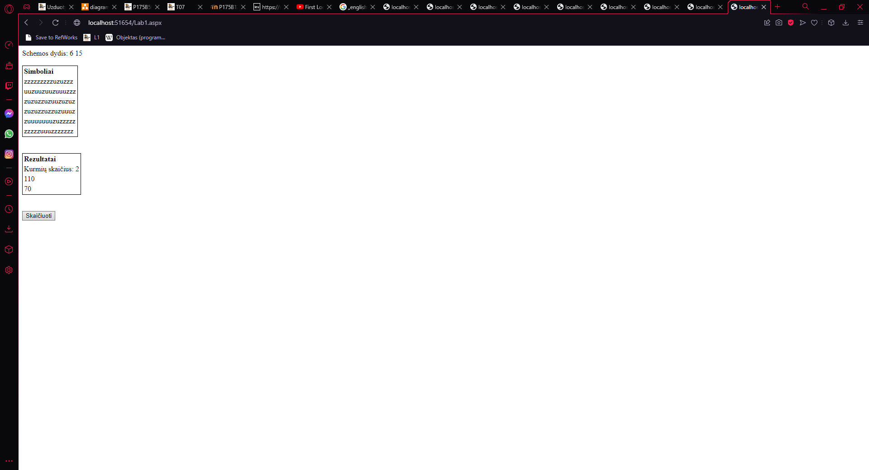

Duomenys nr. 2

U3.txt

3 8

zzzuzzzu

zzuzuuuu

uuzuzzuu

GivenData.txt

-----------------------------------------------

| Eilučių skaičius | Stulpelių skaičius |

-----------------------------------------------

| 3 | 8 |

-----------------------------------------------

| zzzuzzzu |

| zzuzuuuu |

| uuzuzzuu |

------------------------

Rezults.txt

------------------------

| Kurmių skaičius |

------------------------

| 5 |

------------------------

| Kurmių urvų dydžiai |

------------------------

| 35 |

| 10 |

| 5 |

| 5 |

| 5 |

------------------------

Vartotojo sąsaja

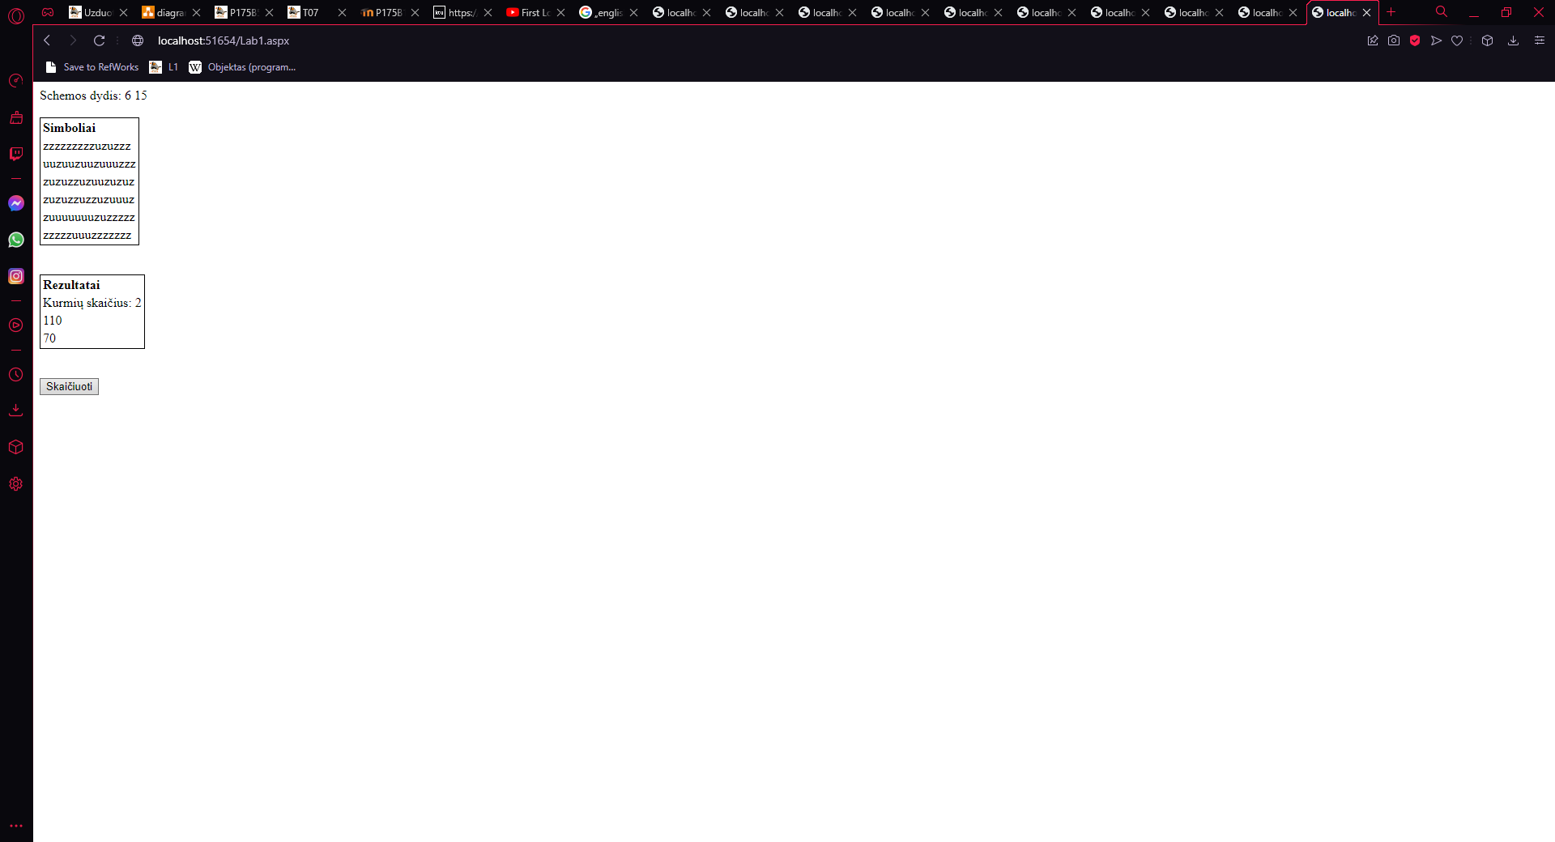

## Dėstytojo pastabos

Savarankiško darbo užduotys: 0.75 / nėra validavimo.

Gynimo testas: 0.0.

Programa: 6.

Ataskaita: 1.

Bendras įvertinimas: 7.

Dėstytojo komentarai:

P2 Sugadintas viršelio šablonas (nėra/bloga dėstytojo pavardės, nėra studento pavardės, neteisingi metai) -0,3. Neteisinga dėstytojo pavardė. P5 Vietoje grafinės naudotojo sąsajos schemos yra pateikta suprogramuotos formos ekrano nuotrauka -0,2. Klasių diagramą reikėtų patobulinti. P8 Nepilnas vartotojo vadovas (duomenys, veiksmų seka, rezultatai) -0,2. P13 Nekomentuoti (arba nepilnai pakomentuoti) metodai -0,2.

# Dinaminis atminties valdymas (L2)

## Darbo užduotis

LD_10. Gamykla. Gamykloje kiekvieną dieną registruojama informacija apie darbininkų pagamintas detales. Darbininkas gali gaminti per dieną skirtingo tipo detales. Suraskite daugiausiai uždirbusio darbininko pavardę, suskaičiuokite, kiek dienų jis dirbo, kiek iš viso detalių pagamino ir už kokią sumą. Sudarykite tik vieno pavadinimo detales gaminusių darbininkų sąrašą, pagamintų detalių skaičių ir sumą. Surikiuokite šį sąrašą pagal pavardes ir vardus. Duomenys:

• Tekstiniame faile U10a.txt surašyta: data (metai, mėnuo, diena), darbininko pavardė ir vardas, detalės kodas, pagamintų vienetų skaičius.

• Tekstiniame faile U10b.txt surašyta: detalės kodas, detalės pavadinimas, įkainis.

Iš duomenų rinkinio faile U10a.txt sudarykite naują duomenų rinkinį pagal nurodytą požymį (pagamintų vienetų skaičius > S, įkainis < K, įvedami klaviatūra). Sąrašas turi būti surikiuotas pagal pavardes ir vardus abėcėlės tvarka.

## Grafinės vartotojo sąsajos schema

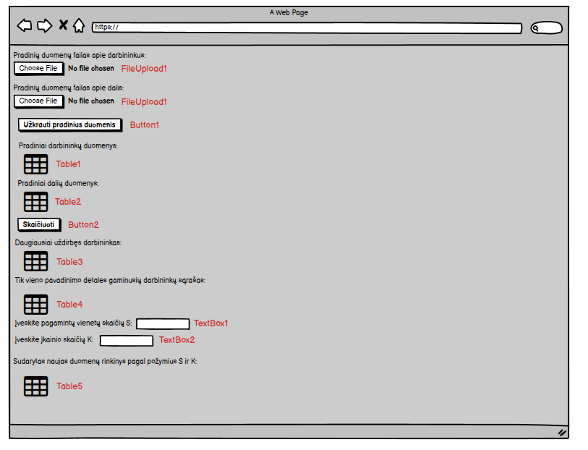

## Sąsajoje panaudotų komponentų keičiamos savybės

|  |  |  |
| --- | --- | --- |
| Komponentas | Savybė | Reikšmė |
| Div | Class | TextSize |
| Body | Backgroud-color | Cadetblue |
| FileUpload1 | CssClass | BoldText |
| FileUpload2 | CssClass | BoldText |
| Button1 | CssClass | BoldText |
| Button1 | Text | Užkrauti pradinius duomenis |
| Table1 | BorderStyle | Solid |
| Table1 | BorderWidth | 1px |
| Table1 | GridLines | Both |
| Table1 | CssClass | Table |
| Table2 | BorderStyle | Solid |
| Table2 | BorderWidth | 1px |
| Table2 | GridLines | Both |
| Table2 | CssClass | Table |
| Table3 | BorderStyle | Solid |
| Table3 | BorderWidth | 1px |
| Table3 | GridLines | Both |
| Table3 | CssClass | Table |
| Table4 | BorderStyle | Solid |
| Table4 | BorderWidth | 1px |
| Table4 | GridLines | Both |
| Table4 | CssClass | Table |
| Table5 | BorderStyle | Solid |
| Table5 | BorderWidth | 1px |
| Table5 | GridLines | Both |
| Table5 | CssClass | Table |
| Button2 | CssClass | BoldText |
| Button2 | Text | Skaičiuoti |

## Klasių diagrama

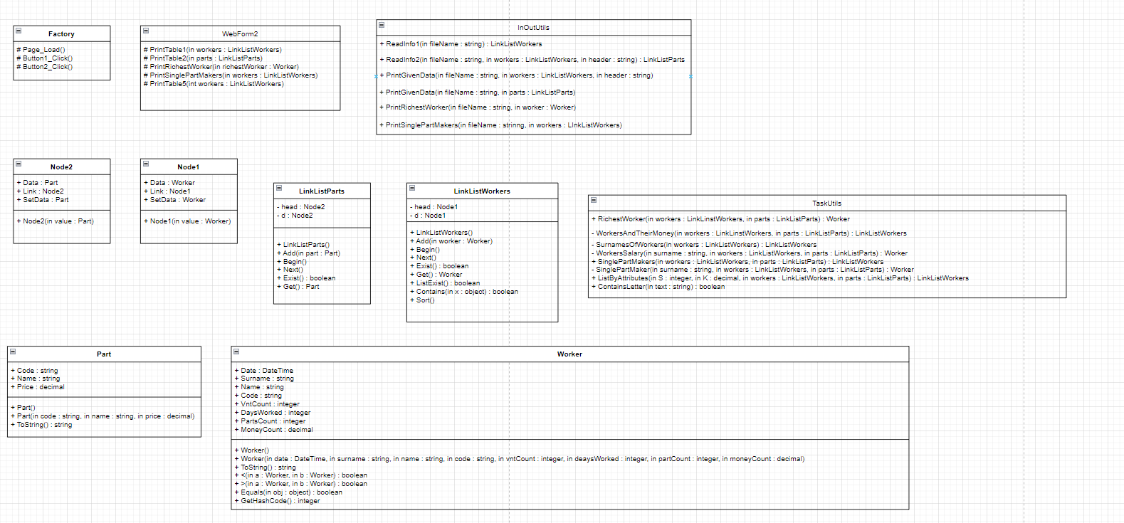

## Programos vartotojo vadovas

Kai atidarome programą, matome dvi vietas įkelti failams. Visų pirma reikia įkelti detalių gamintojų duomenis (U10a.txt), tada detalių duomenis (U10b.txt). Teksto rašymo laukeliuose vartotojas gali įrašyti darbininko pagamintų vienos rūšies detalių skaičių ir detalių įkainio vertę. Užkrovus pradinius duomenis reikia spausti ant mygtuko – užkrauti pradinius duomenis ir tada atsiranda pradinių duomenų lentelė, o į GivenData.txt failą yra išspausdinami pradiniai duomenys. Spustelėjus ant mygtuko – skaičiuoti, atsiranda dar trys lentelės su informacija ir į Rezults.txt failą yra išspausdinami rezultatai. Jeigu pradiniai duomenys nėra užkraunami, tai ir rezultatų failas nėra sukuriamas.

## Programos tekstas

InOutUtils.cs

using System;

using System.Collections.Generic;

using System.Linq;

using System.Web;

using System.IO;

using System.Text;

namespace Lab2

{

/// <summary>

/// Class that prints or reads information

/// </summary>

public static class InOutUtils

{

/// <summary>

/// Creates a list of workers

/// </summary>

/// <param name="fileName">Specific file name of given data</param>

/// <returns>Formated list</returns>

public static LinkListWorkers ReadInfo1(string fileName)

{

LinkListWorkers list = new LinkListWorkers();

string[] lines = File.ReadAllLines(fileName, Encoding.UTF8);

foreach (string line in lines)

{

string[] Values = line.Split(' ');

DateTime date = DateTime.Parse(Values[0]);

string surname = Values[1];

string name = Values[2];

string code = Values[3];

int vntCount = int.Parse(Values[4]);

Worker worker = new Worker(date, surname, name, code, vntCount, 0, 0, 0);

list.Add(worker);

}

return list;

}

/// <summary>

/// Creates a list of different parts

/// </summary>

/// <param name="fileName">Specific file name of given data</param>

/// <returns>Formated list</returns>

public static LinkListParts ReadInfo2(string fileName)

{

LinkListParts list = new LinkListParts();

string[] lines = File.ReadAllLines(fileName, Encoding.UTF8);

foreach (string line in lines)

{

string[] Values = line.Split(' ');

string code = Values[0];

string name = Values[1];

decimal price = decimal.Parse(Values[2]);

Part part = new Part(code, name, price);

list.Add(part);

}

return list;

}

/// <summary>

/// Method that print information about workers to .txt file

/// </summary>

/// <param name="fileName">Specific file name of the place where information will be printed</param>

/// <param name="workers">List of workers</param>

/// <param name="header">Specific header of the information</param>

public static void PrintGivenData(string fileName, LinkListWorkers workers, string header)

{

using (var writer = File.AppendText(fileName))

{

if (header != "")

{

writer.WriteLine(header);

}

writer.WriteLine(new string('-', 116));

for (workers.Begin(); workers.Exist(); workers.Next())

{

writer.WriteLine(workers.Get().ToString());

}

writer.WriteLine(new string('-', 116));

writer.WriteLine();

writer.Close();

}

}

/// <summary>

/// Method that print information about parts to .txt file

/// </summary>

/// <param name="fileName">Specific file name of the place where information will be printed</param>

/// <param name="parts">List of parts</param>

public static void PrintGivenData(string fileName, LinkListParts parts)

{

using (var writer = File.AppendText(fileName))

{

writer.WriteLine(new string('-', 70));

for (parts.Begin(); parts.Exist(); parts.Next())

{

writer.WriteLine(parts.Get().ToString());

}

writer.WriteLine(new string('-', 70));

writer.WriteLine();

writer.Close();

}

}

/// <summary>

/// Method that prints who is the richest worker

/// </summary>

/// <param name="fileName">Specific file name of the place where information will be printed</param>

/// <param name="worker">Information about one worker</param>

public static void PrintRichestWorker(string fileName, Worker worker)

{

using (var writer = File.AppendText(fileName))

{

writer.WriteLine("Daugiausiai uždirbęs darbininkas:");

writer.WriteLine(new string('-', 93));

writer.WriteLine(worker.ToString());

writer.WriteLine(new string('-', 93));

writer.WriteLine();

writer.Close();

}

}

/// <summary>

/// Method that prints information about workers who make only one type of parts

/// </summary>

/// <param name="fileName">Specific file name of the place where information will be printed</param>

/// <param name="workers">List of workers</param>

public static void PrintSinglePartMakers(string fileName, LinkListWorkers workers)

{

using (var writer = File.AppendText(fileName))

{

writer.WriteLine("Tik vieno pavadinimo detales gaminusių darbininkų sąrašas:");

writer.WriteLine(new string('-', 116));

for (workers.Begin(); workers.Exist(); workers.Next())

{

writer.WriteLine(workers.Get().ToString());

}

writer.WriteLine(new string('-', 116));

writer.WriteLine();

writer.Close();

}

}

}

}

Part.cs

using System;

using System.Collections.Generic;

using System.Linq;

using System.Web;

namespace Lab2

{

/// <summary>

/// Parts data class

/// </summary>

public class Part

{

/// <summary>

/// Part's code

/// </summary>

public string Code { get; set; }

/// <summary>

/// Name of the part

/// </summary>

public string Name{ get; set; }

/// <summary>

/// Part's value

/// </summary>

public decimal Price { get; set; }

/// <summary>

/// First constructor

/// </summary>

public Part()

{

}

/// <summary>

/// Second constructor

/// </summary>

/// <param name="code">Part's code</param>

/// <param name="name">Name of the part</param>

/// <param name="price">Part's value</param>

public Part(string code, string name, decimal price)

{

this.Code = code;

this.Name = name;

this.Price = price;

}

/// <summary>

/// Overriden ToString method

/// </summary>

/// <returns>A formated string</returns>

public override string ToString()

{

return string.Format("| {0,-20} | {1,-20} | {2,20} |", Code, Name, Price);

}

}

}

Worker.cs

using System;

using System.Collections.Generic;

using System.Linq;

using System.Web;

namespace Lab2

{

/// <summary>

/// Workers data class

/// </summary>

public class Worker

{

/// <summary>

/// Specific date

/// </summary>

public DateTime Date { get; set; }

/// <summary>

/// Worker's surname

/// </summary>

public string Surname { get; set; }

/// <summary>

/// Worker's name

/// </summary>

public string Name { get; set; }

/// <summary>

/// Part's code

/// </summary>

public string Code { get; set; }

/// <summary>

/// Number of parts

/// </summary>

public int VntCount { get; set; }

/// <summary>

/// Total number of days worked

/// </summary>

public int DaysWorked { get; set; }

/// <summary>

/// Total number of made parts

/// </summary>

public int PartsCount { get; set; }

/// <summary>

/// Total Salary of a worker

/// </summary>

public decimal MoneyCount { get; set; }

/// <summary>

/// First constructor

/// </summary>

public Worker()

{

}

/// <summary>

/// Second constructor

/// </summary>

/// <param name="date">Specific date </param>

/// <param name="surname">Worker's surname</param>

/// <param name="name">Worker's name</param>

/// <param name="code">Part's code</param>

/// <param name="vntCount">Number of parts</param>

/// <param name="daysWorked">Total number of days worked</param>

/// <param name="partCount">Total number of made parts</param>

/// <param name="moneyCount">Total Salary of a worker</param>

public Worker(DateTime date, string surname, string name, string code, int vntCount, int daysWorked, int partCount, decimal moneyCount)

{

this.Date = date;

this.Surname = surname;

this.Name = name;

this.Code = code;

this.VntCount = vntCount;

this.DaysWorked = daysWorked;

this.PartsCount = partCount;

this.MoneyCount = moneyCount;

}

/// <summary>

/// Overriden ToString method

/// </summary>

/// <returns>A formated string</returns>

public override string ToString()

{

if (Date != DateTime.MinValue)

{

return string.Format("| {0,-20:yyyy-MM-dd} | {1,-20} | {2,-20} | {3,-20} | {4,20} |", Date, Surname, Name, Code, VntCount);

}

else if (Name == null)

{

return string.Format("| {0,-20} | {1,20} | {2,20} | {3,20} |", Surname, DaysWorked, PartsCount, MoneyCount);

}

else

return string.Format("| {0,-20} | {1,-20} | {2,-20} | {3,20} | {4,20} |", Surname, Name, Code, PartsCount, MoneyCount);

}

/// <summary>

/// Overloading operator <

/// </summary>

/// <param name="a">First worker</param>

/// <param name="b">Second worker</param>

/// <returns>If it is true or false</returns>

public static bool operator <(Worker a, Worker b)

{

if (a.Surname != b.Surname)

{

return a.Surname.CompareTo(b.Surname) < 0;

}

else return a.Name.CompareTo(b.Name) < 0;

}

/// <summary>

/// Overloading operator >

/// </summary>

/// <param name="a">First worker</param>

/// <param name="b">Second worker</param>

/// <returns>If it is true or false</returns>

public static bool operator >(Worker a, Worker b)

{

if (a.Surname != b.Surname)

{

return a.Surname.CompareTo(b.Surname) > 0;

}

else return a.Name.CompareTo(b.Name) > 0;

}

/// <summary>

/// Overriden Equals method

/// </summary>

/// <param name="obj">An object type variable</param>

/// <returns>If it is true or false</returns>

public override bool Equals(object obj)

{

if (Surname.Equals(obj) == true)

{

return true;

}

else if (Code.Equals(obj) == true)

{

return true;

}

else if (Date.Equals(obj) == true)

{

return true;

}

return false;

}

/// <summary>

/// Overriden GetHashCode method

/// </summary>

/// <returns>Int type value</returns>

public override int GetHashCode()

{

return base.GetHashCode();

}

}

}

Node1.cs

using System;

using System.Collections.Generic;

using System.Linq;

using System.Web;

namespace Lab2

{

/// <summary>

/// Workers node class

/// </summary>

public sealed class Node1

{

/// <summary>

/// Data about a worker

/// </summary>

public Worker Data { get; private set; }

/// <summary>

/// A link to further information about workers

/// </summary>

public Node1 Link { get; set; }

/// <summary>

/// Constructor

/// </summary>

/// <param name="value">One worker's information</param>

public Node1(Worker value)

{

this.Data = value;

this.Link = null;

}

/// <summary>

/// Allows to define data's information

/// </summary>

public Worker SetData

{

set { this.Data = value; }

}

}

}

Node2.cs

using System;

using System.Collections.Generic;

using System.Linq;

using System.Web;

namespace Lab2

{

/// <summary>

/// Parts node class

/// </summary>

public sealed class Node2

{

/// <summary>

/// Data about a part

/// </summary>

public Part Data { get; private set; }

/// <summary>

/// A link to further information about parts

/// </summary>

public Node2 Link { get; set; }

/// <summary>

/// Constructor

/// </summary>

/// <param name="value">One part's information</param>

public Node2(Part value)

{

this.Data = value;

this.Link = null;

}

/// <summary>

/// Allows to define data's information

/// </summary>

public Part SetData

{

set { this.Data = value; }

}

}

}

LinkListWorkers.cs

using System;

using System.Collections.Generic;

using System.Linq;

using System.Web;

namespace Lab2

{

/// <summary>

/// Class that formats a list of workers

/// </summary>

public sealed class LinkListWorkers

{

/// <summary>

/// Head of the information

/// </summary>

private Node1 head;

/// <summary>

/// Created for interface of list

/// </summary>

private Node1 d;

/// <summary>

/// Constructor

/// </summary>

public LinkListWorkers()

{

this.head = new Node1(new Worker());

this.d = null;

}

/// <summary>

/// Method that adds information to the list

/// </summary>

/// <param name="worker">One worker</param>

public void Add(Worker worker)

{

Node1 current = head;

while (current.Link != null)

{

current = current.Link;

}

current.Link = new Node1(worker);

}

/// <summary>

/// Address of the head of the list is assigned

/// </summary>

public void Begin()

{

d = head.Link;

}

/// <summary>

/// Interface variable gets address of the next entry

/// </summary>

public void Next()

{

d = d.Link;

}

/// <summary>

/// Return true, if list is empty

/// </summary>

/// <returns>If it's true or false</returns>

public bool Exist()

{

return d != null;

}

/// <summary>

/// Method that return data according to the interface address

/// </summary>

/// <returns>Data of one worker</returns>

public Worker Get()

{

return d.Data;

}

/// <summary>

/// Return true if list has data

/// </summary>

/// <returns>If it's true or false</returns>

public bool ListExist()

{

if (this.head.Link != null)

{

return true;

}

return false;

}

/// <summary>

/// Method that finds out if list has specific data or not

/// </summary>

/// <param name="x">Specific data</param>

/// <returns>If it is true or false</returns>

public bool Contains(object x)

{

for (Node1 current = head.Link; current != null; current = current.Link)

{

if (current.Data.Equals(x))

{

return true;

}

}

return false;

}

/// <summary>

/// Method that sorts the list

/// </summary>

public void Sort()

{

for (Node1 d1 = head; d1 != null; d1 = d1.Link)

{

Node1 min = d1;

for (Node1 d2 = d1.Link; d2 != null; d2 = d2.Link)

{

if (d2.Data < min.Data)

{

min = d2;

}

}

Worker worker = d1.Data;

d1.SetData = min.Data;

min.SetData = worker;

}

}

}

}

LinkListParts.cs

using System;

using System.Collections.Generic;

using System.Linq;

using System.Web;

namespace Lab2

{

/// <summary>

/// Class that formats a list of parts

/// </summary>

public sealed class LinkListParts

{

/// <summary>

/// Head of the information

/// </summary>

private Node2 head;

/// <summary>

/// Created for interface of list

/// </summary>

private Node2 d;

/// <summary>

/// Constructor

/// </summary>

public LinkListParts()

{

this.head = new Node2(new Part());

this.d = null;

}

/// <summary>

/// Method that adds information to the list

/// </summary>

/// <param name="part">Single part</param>

public void Add(Part part)

{

Node2 current = head;

while (current.Link != null)

{

current = current.Link;

}

current.Link = new Node2(part);

}

/// <summary>

/// Address of the head of the list is assigned

/// </summary>

public void Begin()

{

d = head.Link;

}

/// <summary>

/// Interface variable gets address of the next entry

/// </summary>

public void Next()

{

d = d.Link;

}

/// <summary>

/// Return true, if list is empty

/// </summary>

/// <returns>If it's true or false</returns>

public bool Exist()

{

return d != null;

}

/// <summary>

/// Method that return data according to the interface address

/// </summary>

/// <returns>Data of one part</returns>

public Part Get()

{

return d.Data;

}

}

}

TaskUtils.cs

using System;

using System.Collections.Generic;

using System.Linq;

using System.Web;

namespace Lab2

{

/// <summary>

/// Class where calculations are being made

/// </summary>

public static class TaskUtils

{

/// <summary>

/// Method that finds the richest worker

/// </summary>

/// <param name="workers">List of workers</param>

/// <param name="parts">List of parts</param>

/// <returns>One worker</returns>

public static Worker RichestWorker(LinkListWorkers workers, LinkListParts parts)

{

LinkListWorkers workersAndTheirMoney = WorkersAndTheirMoney(workers, parts);

Worker worker = new Worker();

decimal money = 0;

for (workersAndTheirMoney.Begin(); workersAndTheirMoney.Exist(); workersAndTheirMoney.Next())

{

if (workersAndTheirMoney.Get().MoneyCount > money)

{

money = workersAndTheirMoney.Get().MoneyCount;

worker = workersAndTheirMoney.Get();

}

}

return worker;

}

/// <summary>

/// Method that formats a list of workers and their salaries

/// </summary>

/// <param name="workers">List of workers</param>

/// <param name="parts">List of parts</param>

/// <returns>A list</returns>

private static LinkListWorkers WorkersAndTheirMoney(LinkListWorkers workers, LinkListParts parts)

{

LinkListWorkers listOfWorkers = new LinkListWorkers();

LinkListWorkers surnamesOfWorkers = SurnamesOfWorkers(workers);

for (surnamesOfWorkers.Begin(); surnamesOfWorkers.Exist(); surnamesOfWorkers.Next())

{

Worker worker = WorkersSalary(surnamesOfWorkers.Get().Surname, workers, parts);

listOfWorkers.Add(worker);

}

return listOfWorkers;

}

/// <summary>

/// Method that formats a list of workers who can repeat only once

/// </summary>

/// <param name="workers">List of workers</param>

/// <returns>A list</returns>

private static LinkListWorkers SurnamesOfWorkers(LinkListWorkers workers)

{

LinkListWorkers surnames = new LinkListWorkers();

for (workers.Begin(); workers.Exist(); workers.Next())

{

if (!surnames.Contains(workers.Get().Surname))

{

surnames.Add(workers.Get());

}

}

return surnames;

}

/// <summary>

/// Method that count's worker's salary

/// </summary>

/// <param name="surname">Worker's surname</param>

/// <param name="workers">List of workers</param>

/// <param name="parts">List of parts</param>

/// <returns>One worker</returns>

private static Worker WorkersSalary(string surname, LinkListWorkers workers, LinkListParts parts)

{

int DaysWorked = 0;

int PartsCount = 0;

decimal MoneyCount = 0;

LinkListWorkers date = new LinkListWorkers();

for (workers.Begin(); workers.Exist(); workers.Next())

{

if (workers.Get().Surname == surname)

{

decimal money = 0;

PartsCount = PartsCount + workers.Get().VntCount;

for (parts.Begin(); parts.Exist(); parts.Next())

{

if (workers.Get().Code == parts.Get().Code)

{

money = workers.Get().VntCount * parts.Get().Price;

}

}

MoneyCount = MoneyCount + money;

if (!date.Contains(workers.Get().Date))

{

date.Add(workers.Get());

DaysWorked++;

}

}

}

Worker worker = new Worker(DateTime.MinValue, surname, null, null, 0, DaysWorked, PartsCount, MoneyCount);

return worker;

}

/// <summary>

/// Method that formats a list of workers who make only one type of parts

/// </summary>

/// <param name="workers">List of workers</param>

/// <param name="parts">List of parts</param>

/// <returns>Formated list</returns>

public static LinkListWorkers SinglePartMakers(LinkListWorkers workers, LinkListParts parts)

{

LinkListWorkers singlePartsWorkers = new LinkListWorkers();

LinkListWorkers surnamesOfWorkers = SurnamesOfWorkers(workers);

for (surnamesOfWorkers.Begin(); surnamesOfWorkers.Exist(); surnamesOfWorkers.Next())

{

Worker worker = SinglePartMaker(surnamesOfWorkers.Get().Surname, workers, parts);

if (worker != null)

{

singlePartsWorkers.Add(worker);

}

}

return singlePartsWorkers;

}

/// <summary>

/// Method that finds workers who make only one type of parts

/// </summary>

/// <param name="surname">Worker's surname</param>

/// <param name="workers">List of workers</param>

/// <param name="parts">List of parts</param>

/// <returns>A worker</returns>

private static Worker SinglePartMaker(string surname, LinkListWorkers workers, LinkListParts parts)

{

LinkListWorkers onePartMaker = new LinkListWorkers();

Worker worker = new Worker();

int totalNumberOfParts = 0;

decimal moneyCount = 0;

int howManyParts = 0;

for (workers.Begin(); workers.Exist(); workers.Next())

{

if (workers.Get().Surname == surname && !onePartMaker.Contains(workers.Get().Code))

{

onePartMaker.Add(workers.Get());

howManyParts++;

}

if (workers.Get().Surname == surname)

{

decimal money = 0;

totalNumberOfParts = totalNumberOfParts + workers.Get().VntCount;

for (parts.Begin(); parts.Exist(); parts.Next())

{

if (workers.Get().Code == parts.Get().Code)

{

money = workers.Get().VntCount * parts.Get().Price;

}

}

moneyCount = moneyCount + money;

worker = new Worker(DateTime.MinValue, workers.Get().Surname, workers.Get().Name, workers.Get().Code, 0, 0, totalNumberOfParts, moneyCount);

}

}

if (howManyParts == 1)

{

return worker;

}

return null;

}

/// <summary>

/// Method that formats a list of workers defined by attributes

/// </summary>

/// <param name="S">Number of parts</param>

/// <param name="K">Value of price</param>

/// <param name="workers">List of workers</param>

/// <param name="parts">List of parts</param>

/// <returns>A list</returns>

public static LinkListWorkers ListByAttributes(int S, decimal K, LinkListWorkers workers, LinkListParts parts)

{

LinkListWorkers listOfWorkers = new LinkListWorkers();

for (workers.Begin(); workers.Exist(); workers.Next())

{

if (workers.Get().VntCount > S)

{

for (parts.Begin(); parts.Exist(); parts.Next())

{

if (workers.Get().Code == parts.Get().Code && parts.Get().Price < K)

{

listOfWorkers.Add(workers.Get());

}

}

}

}

return listOfWorkers;

}

/// <summary>

/// Method that finds out if a string type variable has a specific symbol and returns true or false

/// </summary>

/// <param name="text">String type variable</param>

/// <returns>If it is true or false</returns>

public static bool ContainsLetter(string text)

{

string alphabet = "ABCDEFGHIJKLMNOPQRSTUVWXYZabcdefghjklmnopqrstuvwxyząčęėįšųūžĄČĘĖĮŠŲŪŽ";

foreach (char a in alphabet)

{

if (text.Contains(a))

{

return true;

}

}

return false;

}

}

}

WebForm2.cs

using System;

using System.Collections.Generic;

using System.Linq;

using System.Web;

using System.Web.UI;

using System.Web.UI.WebControls;

using System.IO;

namespace Lab2

{

/// <summary>

/// Web form extention

/// </summary>

public partial class Factory : System.Web.UI.Page

{

/// <summary>

/// Method that forms Table1

/// </summary>

/// <param name="workers">List of wrokers</param>

protected void PrintTable1(LinkListWorkers workers)

{

TableRow row = new TableRow();

TableCell cell1 = new TableCell();

cell1.Text = "<b>Data</b>";

row.Cells.Add(cell1);

TableCell cell2 = new TableCell();

cell2.Text = "<b>Pavardė</b>";

row.Cells.Add(cell2);

TableCell cell3 = new TableCell();

cell3.Text = "<b>Vardas</b>";

row.Cells.Add(cell3);

TableCell cell4 = new TableCell();

cell4.Text = "<b>Kodas</b>";

row.Cells.Add(cell4);

TableCell cell5 = new TableCell();

cell5.Text = "<b>Detalių skaičius</b>";

row.Cells.Add(cell5);

Table1.Rows.Add(row);

for (workers.Begin(); workers.Exist(); workers.Next())

{

TableRow newRow = new TableRow();

TableCell newCell1 = new TableCell();

newCell1.Text = string.Format("{0:yyyy-MM-dd}", workers.Get().Date);

newRow.Cells.Add(newCell1);

TableCell newCell2 = new TableCell();

newCell2.Text = string.Format("{0}", workers.Get().Surname);

newRow.Cells.Add(newCell2);

TableCell newCell3 = new TableCell();

newCell3.Text = string.Format("{0}", workers.Get().Name);

newRow.Cells.Add(newCell3);

TableCell newCell4 = new TableCell();

newCell4.Text = string.Format("{0}", workers.Get().Code);

newRow.Cells.Add(newCell4);

TableCell newCell5 = new TableCell();

newCell5.Text = string.Format("{0}", workers.Get().VntCount);

newRow.Cells.Add(newCell5);

Table1.Rows.Add(newRow);

}

}

/// <summary>

/// Method that forms Table2

/// </summary>

/// <param name="parts">List of parts</param>

protected void PrintTable2(LinkListParts parts)

{

TableRow row = new TableRow();

TableCell cell1 = new TableCell();

cell1.Text = "<b>Kodas</b>";

row.Cells.Add(cell1);

TableCell cell2 = new TableCell();

cell2.Text = "<b>Pavadinimas</b>";

row.Cells.Add(cell2);

TableCell cell3 = new TableCell();

cell3.Text = "<b>Kaina</b>";

row.Cells.Add(cell3);

Table2.Rows.Add(row);

for (parts.Begin(); parts.Exist(); parts.Next())

{

TableRow newRow = new TableRow();

TableCell newCell1 = new TableCell();

newCell1.Text = string.Format("{0}", parts.Get().Code);

newRow.Cells.Add(newCell1);

TableCell newCell2 = new TableCell();

newCell2.Text = string.Format("{0}", parts.Get().Name);

newRow.Cells.Add(newCell2);

TableCell newCell3 = new TableCell();

newCell3.Text = string.Format("{0}", parts.Get().Price);

newRow.Cells.Add(newCell3);

Table2.Rows.Add(newRow);

}

}

/// <summary>

/// Method that forms Table3

/// </summary>

/// <param name="richestWorker">A single worker</param>

protected void PrintRichestWorker(Worker richestWorker)

{

TableRow row = new TableRow();

TableCell cell1 = new TableCell();

cell1.Text = "<b>Pavardė</b>";

row.Cells.Add(cell1);

TableCell cell2 = new TableCell();

cell2.Text = "<b>Dirbtų dienų skaičius</b>";

row.Cells.Add(cell2);

TableCell cell3 = new TableCell();

cell3.Text = "<b>Pagamintų detalių skaičius</b>";

row.Cells.Add(cell3);

TableCell cell4 = new TableCell();

cell4.Text = "<b>Uždirbti pinigai</b>";

row.Cells.Add(cell4);

Table3.Rows.Add(row);

if (richestWorker.Surname != null)

{

TableRow newRow = new TableRow();

TableCell cell5 = new TableCell();

cell5.Text = string.Format("{0}", richestWorker.Surname);

newRow.Cells.Add(cell5);

TableCell cell6 = new TableCell();

cell6.Text = string.Format("{0}", richestWorker.DaysWorked);

newRow.Cells.Add(cell6);

TableCell cell7 = new TableCell();

cell7.Text = string.Format("{0}", richestWorker.PartsCount);

newRow.Cells.Add(cell7);

TableCell cell8 = new TableCell();

cell8.Text = string.Format("{0}", richestWorker.MoneyCount);

newRow.Cells.Add(cell8);

Table3.Rows.Add(newRow);

}

}

/// <summary>

/// Method that forms Table4

/// </summary>

/// <param name="workers">List of workers</param>

protected void PrintSinglePartMakers(LinkListWorkers workers)

{

TableRow row = new TableRow();

TableCell cell1 = new TableCell();

cell1.Text = "<b>Pavardė</b>";

row.Cells.Add(cell1);

TableCell cell2 = new TableCell();

cell2.Text = "<b>Vardas</b>";

row.Cells.Add(cell2);

TableCell cell3 = new TableCell();

cell3.Text = "<b>Detalės kodas</b>";

row.Cells.Add(cell3);

TableCell cell4 = new TableCell();

cell4.Text = "<b>Skaičius vienodų detalių</b>";

row.Cells.Add(cell4);

TableCell cell5 = new TableCell();

cell5.Text = "<b>Uždirbtų pinigų suma</b>";

row.Cells.Add(cell5);

Table4.Rows.Add(row);

for (workers.Begin(); workers.Exist(); workers.Next())

{

TableRow newRow = new TableRow();

TableCell newCell1 = new TableCell();

newCell1.Text = string.Format("{0}", workers.Get().Surname);

newRow.Cells.Add(newCell1);

TableCell newCell2 = new TableCell();

newCell2.Text = string.Format("{0}", workers.Get().Name);

newRow.Cells.Add(newCell2);

TableCell newCell3 = new TableCell();

newCell3.Text = string.Format("{0}", workers.Get().Code);

newRow.Cells.Add(newCell3);

TableCell newCell4 = new TableCell();

newCell4.Text = string.Format("{0}", workers.Get().PartsCount);

newRow.Cells.Add(newCell4);

TableCell newCell5 = new TableCell();

newCell5.Text = string.Format("{0}", workers.Get().MoneyCount);

newRow.Cells.Add(newCell5);

Table4.Rows.Add(newRow);

}

}

/// <summary>

/// Method that forms Table5

/// </summary>

/// <param name="workers">List of workers</param>

protected void PrintTable5(LinkListWorkers workers)

{

TableRow row = new TableRow();

TableCell cell1 = new TableCell();

cell1.Text = "<b>Data</b>";

row.Cells.Add(cell1);

TableCell cell2 = new TableCell();

cell2.Text = "<b>Pavardė</b>";

row.Cells.Add(cell2);

TableCell cell3 = new TableCell();

cell3.Text = "<b>Vardas</b>";

row.Cells.Add(cell3);

TableCell cell4 = new TableCell();

cell4.Text = "<b>Kodas</b>";

row.Cells.Add(cell4);

TableCell cell5 = new TableCell();

cell5.Text = "<b>Detalių skaičius</b>";

row.Cells.Add(cell5);

Table5.Rows.Add(row);

for (workers.Begin(); workers.Exist(); workers.Next())

{

TableRow newRow = new TableRow();

TableCell newCell1 = new TableCell();

newCell1.Text = string.Format("{0:yyyy-MM-dd}", workers.Get().Date);

newRow.Cells.Add(newCell1);

TableCell newCell2 = new TableCell();

newCell2.Text = string.Format("{0}", workers.Get().Surname);

newRow.Cells.Add(newCell2);

TableCell newCell3 = new TableCell();

newCell3.Text = string.Format("{0}", workers.Get().Name);

newRow.Cells.Add(newCell3);

TableCell newCell4 = new TableCell();

newCell4.Text = string.Format("{0}", workers.Get().Code);

newRow.Cells.Add(newCell4);

TableCell newCell5 = new TableCell();

newCell5.Text = string.Format("{0}", workers.Get().VntCount);

newRow.Cells.Add(newCell5);

Table5.Rows.Add(newRow);

}

}

}

}

StyleSheet1.css

div {

background-color :mistyrose;

}

.Table{

background-color: yellow;

}

.BoldText{

font-weight: bold;

}

body{

background-color: cadetblue;

}

.TextSize{

font-size: 18px;

}

Factory.aspx

<%@ Page Language="C#" AutoEventWireup="true" CodeBehind="Factory.aspx.cs" Inherits="Lab2.Factory" %>

<!DOCTYPE html>

<html xmlns="http://www.w3.org/1999/xhtml">

<head runat="server">

<title></title>

<link href="StyleSheet1.css" rel="stylesheet" type="text/css" />

</head>

<body>

<form id="form1" runat="server">

<div class="TextSize">

Pradinių duomenų failas apie darbininkus:<br />

<asp:FileUpload ID="FileUpload1" runat="server" CssClass="BoldText" />

<br />

<br />

Pradinių duomenų failas apie dalis:<br />

<asp:FileUpload ID="FileUpload2" runat="server" CssClass="BoldText" />

<br />

<br />

&nbsp;<asp:Button ID="Button1" runat="server" Text="Užkrauti pradinius duomenis" OnClick="Button1_Click" CssClass="BoldText" />

<br />

<br />

Pradiniai darbininkų duomenys:<br />

<asp:Table ID="Table1" runat="server" BorderStyle="Solid" BorderWidth="1px" GridLines="Both" CssClass="Table">

</asp:Table>

<br />

Pradiniai dalių duomenys:<asp:Table ID="Table2" runat="server" BorderStyle="Solid" BorderWidth="1px" GridLines="Both" CssClass="Table">

</asp:Table>

<br />

<asp:Button ID="Button2" runat="server" OnClick="Button2_Click" Text="Skaičiuoti" CssClass="BoldText" />

<br />

<br />

Daugiausiai uždirbęs darbininkas:<br />

<asp:Table ID="Table3" runat="server" BorderStyle="Solid" BorderWidth="1px" GridLines="Both" CssClass="Table">

</asp:Table>

<br />

Tik vieno pavadinimo detales gaminusių darbininkų sąrašas:<br />

<asp:Table ID="Table4" runat="server" BorderStyle="Solid" BorderWidth="1px" GridLines="Both" CssClass="Table">

</asp:Table>

<br />

Įveskite pagamintų vienetų skaičių S:

<asp:TextBox ID="TextBox1" runat="server"></asp:TextBox>

<br />

<br />

Įveskite įkainio skaičių K:

<asp:TextBox ID="TextBox2" runat="server"></asp:TextBox>

<br />

<br />

Sudarytas naujas duomenų rinkinys pagal požymius S ir K:<asp:Table ID="Table5" runat="server" BorderStyle="Solid" BorderWidth="1px" GridLines="Both" CssClass="Table">

</asp:Table>

<br />

</div>

</form>

</body>

</html>

Factory.aspx.cs

using System;

using System.Collections.Generic;

using System.Linq;

using System.Web;

using System.Web.UI;

using System.Web.UI.WebControls;

using System.IO;

//Main function of this program is to do all kinds of calculations with given data of workers and different parts

//Vytenis Kriščiūnas

namespace Lab2

{

/// <summary>

/// Web form

/// </summary>

public partial class Factory : System.Web.UI.Page

{

/// <summary>

/// List of parts

/// </summary>

LinkListParts parts;

/// <summary>

/// List of workers

/// </summary>

LinkListWorkers workers;

/// <summary>

/// The richest worker

/// </summary>

Worker richestWorker;

/// <summary>

/// List of workers who allways make the same parts

/// </summary>

LinkListWorkers singlePartMakers;

/// <summary>

/// List formed by given attributes

/// </summary>

LinkListWorkers listByAttributes;

/// <summary>

/// Prints information to the screen when page loads

/// </summary>

/// <param name="sender">An object variable</param>

/// <param name="e">EventArgs variable</param>

protected void Page_Load(object sender, EventArgs e)

{

if (parts == null)

{

parts = new LinkListParts();

}

if (workers == null)

{

workers = new LinkListWorkers();

}

if (richestWorker == null)

{

richestWorker = new Worker();

}

if (singlePartMakers == null)

{

singlePartMakers = new LinkListWorkers();

}

if (listByAttributes == null)

{

listByAttributes = new LinkListWorkers();

}

parts = Session["parts"] as LinkListParts;

workers = Session["workers"] as LinkListWorkers;

if (workers != null && parts != null)

{

PrintTable1(workers);

PrintTable2(parts);

}

}

/// <summary>

/// Prints and reads given information when the first button is clicked

/// </summary>

/// <param name="sender">An object variable</param>

/// <param name="e">EventArgs variable</param>

protected void Button1_Click(object sender, EventArgs e)

{

Session.Remove("parts");

Session.Remove("workers");

for (int i = Table1.Rows.Count - 1; i >= 0; i--)

{

Table1.Rows.RemoveAt(i);

}

for (int i = Table2.Rows.Count - 1; i >= 0; i--)

{

Table2.Rows.RemoveAt(i);

}

string Fr = Server.MapPath("App_Data/GivenData.txt");

File.Delete(Fr);

if (FileUpload1.HasFile && FileUpload2.HasFile)

{

string Fd1 = Server.MapPath("App_Data/U10a.txt"); // workers

string Fd2 = Server.MapPath("App_Data/U10b.txt"); // parts

if (FileUpload1.FileName.EndsWith("a.txt") && FileUpload2.FileName.EndsWith("b.txt"))

{

parts = InOutUtils.ReadInfo2(Fd2);

workers = InOutUtils.ReadInfo1(Fd1);

PrintTable1(workers);

PrintTable2(parts);

InOutUtils.PrintGivenData(Fr, workers, "");

InOutUtils.PrintGivenData(Fr, parts);

Session["parts"] = parts;

Session["workers"] = workers;

}

}

}

/// <summary>

/// Calculates needed information and prints it when the second button is clicked

/// </summary>

/// <param name="sender"></param>

/// <param name="e"></param>

protected void Button2_Click(object sender, EventArgs e)

{

string Fr = Server.MapPath("App_Data/Rezults.txt");

File.Delete(Fr);

int S = 0;

decimal K = 0;

if (TextBox1.Text != "" && TextBox2.Text != "" && TaskUtils.ContainsLetter(TextBox1.Text) == false && TaskUtils.ContainsLetter(TextBox2.Text) == false)

{

S = int.Parse(TextBox1.Text);

K = decimal.Parse(TextBox2.Text);

}

if (workers != null && parts != null)

{

richestWorker = TaskUtils.RichestWorker(workers, parts);

singlePartMakers = TaskUtils.SinglePartMakers(workers, parts);

singlePartMakers.Sort();

}

PrintRichestWorker(richestWorker);

PrintSinglePartMakers(singlePartMakers);

if (workers != null && parts != null && S != 0 && K != 0)

{

listByAttributes = TaskUtils.ListByAttributes(S, K, workers, parts);

listByAttributes.Sort();

}

PrintTable5(listByAttributes);

if (richestWorker.Surname != null)

{

InOutUtils.PrintRichestWorker(Fr, richestWorker);

}

if (singlePartMakers.ListExist() == true)

{

InOutUtils.PrintSinglePartMakers(Fr, singlePartMakers);

}

if (listByAttributes.ListExist() == true)

{

InOutUtils.PrintGivenData(Fr, listByAttributes, string.Format("Sudarytas naujas duomenų rinkinys pagal požymius S ir K:"));

}

if (richestWorker.Surname == null && singlePartMakers.ListExist() == false && listByAttributes.ListExist() == false)

{

File.Delete(Fr);

}

}

}

}

## Pradiniai duomenys ir rezultatai

Duomenys nr. 1

U10a.txt

2021-07-21 Pavardenis Vardenis IOp5 5

2021-07-21 Pavardenis Vardenis LkD5 4

2021-07-21 Kazkoks Kazkas LkD5 4

2021-06-21 Kazkoks Kazkas LkD5 4

2021-06-21 Kazkoks Kazkas LkD5 7

2022-06-21 Aetraitis Petras Klj 7

U10b.txt

IOp5 metal 3

LkD5 plast 6.3

Bpm6 kalp 2

Klj milst 9.3

GivenData.txt

--------------------------------------------------------------------------------------------------------------------

| 2021-07-21 | Pavardenis | Vardenis | IOp5 | 5 |

| 2021-07-21 | Pavardenis | Vardenis | LkD5 | 4 |

| 2021-07-21 | Kazkoks | Kazkas | LkD5 | 4 |

| 2021-06-21 | Kazkoks | Kazkas | LkD5 | 4 |

| 2021-06-21 | Kazkoks | Kazkas | LkD5 | 7 |

| 2022-06-21 | Aetraitis | Petras | Klj | 7 |

--------------------------------------------------------------------------------------------------------------------

----------------------------------------------------------------------

| IOp5 | metal | 3 |

| LkD5 | plast | 6.3 |

| Bpm6 | kalp | 2 |

| Klj | milst | 9.3 |

----------------------------------------------------------------------

Rezults.txt

Daugiausiai uždirbęs darbininkas:

---------------------------------------------------------------------------------------------

| Kazkoks | 2 | 15 | 94.5 |

---------------------------------------------------------------------------------------------

Tik vieno pavadinimo detales gaminusių darbininkų sąrašas:

--------------------------------------------------------------------------------------------------------------------

| Aetraitis | Petras | Klj | 7 | 65.1 |

| Kazkoks | Kazkas | LkD5 | 15 | 94.5 |

--------------------------------------------------------------------------------------------------------------------

Sudarytas naujas duomenų rinkinys pagal požymius S ir K:

--------------------------------------------------------------------------------------------------------------------

| 2022-06-21 | Aetraitis | Petras | Klj | 7 |

| 2021-07-21 | Kazkoks | Kazkas | LkD5 | 4 |

| 2021-06-21 | Kazkoks | Kazkas | LkD5 | 4 |

| 2021-06-21 | Kazkoks | Kazkas | LkD5 | 7 |

| 2021-07-21 | Pavardenis | Vardenis | LkD5 | 4 |

| 2021-07-21 | Pavardenis | Vardenis | IOp5 | 5 |

--------------------------------------------------------------------------------------------------------------------

Vartotojo sąsaja

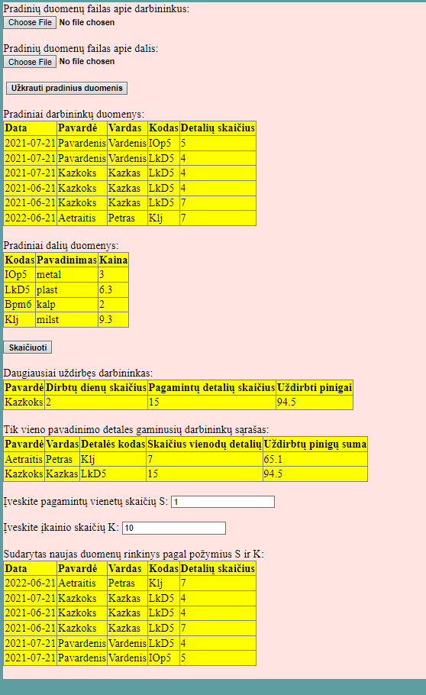

Duomenys nr. 2

U10a.txt

2021-07-21 Pavardenis Vardenis IOp5 5

2021-07-21 Pavardenis Vardenis LkD5 4

2021-07-21 Bazkoks Lazkas Bpm6 4

2021-06-21 Bazkoks Lazkas LkD5 4

2021-06-21 Bazkoks Lazkas LkD5 7

2022-06-21 Aetraitis Petras Klj 7

2022-06-28 Valancius Justas IOp5 8

U10b.txt

IOp5 metal 3

LkD5 plast 2

Bpm6 kalp 2

Klj milst 9.3

GivenData.txt

--------------------------------------------------------------------------------------------------------------------

| 2021-07-21 | Pavardenis | Vardenis | IOp5 | 5 |

| 2021-07-21 | Pavardenis | Vardenis | LkD5 | 4 |

| 2021-07-21 | Bazkoks | Lazkas | Bpm6 | 4 |

| 2021-06-21 | Bazkoks | Lazkas | LkD5 | 4 |

| 2021-06-21 | Bazkoks | Lazkas | LkD5 | 7 |

| 2022-06-21 | Aetraitis | Petras | Klj | 7 |

| 2022-06-28 | Valancius | Justas | IOp5 | 8 |

--------------------------------------------------------------------------------------------------------------------

----------------------------------------------------------------------

| IOp5 | metal | 3 |

| LkD5 | plast | 2 |

| Bpm6 | kalp | 2 |

| Klj | milst | 9.3 |

----------------------------------------------------------------------

Rezults.txt

Daugiausiai uždirbęs darbininkas:

---------------------------------------------------------------------------------------------

| Aetraitis | 1 | 7 | 65.1 |

---------------------------------------------------------------------------------------------

Tik vieno pavadinimo detales gaminusių darbininkų sąrašas:

--------------------------------------------------------------------------------------------------------------------

| Aetraitis | Petras | Klj | 7 | 65.1 |

| Valancius | Justas | IOp5 | 8 | 24 |

--------------------------------------------------------------------------------------------------------------------

Sudarytas naujas duomenų rinkinys pagal požymius S ir K:

--------------------------------------------------------------------------------------------------------------------

| 2021-06-21 | Bazkoks | Lazkas | LkD5 | 7 |

| 2021-07-21 | Pavardenis | Vardenis | IOp5 | 5 |

| 2022-06-28 | Valancius | Justas | IOp5 | 8 |

--------------------------------------------------------------------------------------------------------------------

Vartotojo sąsaja

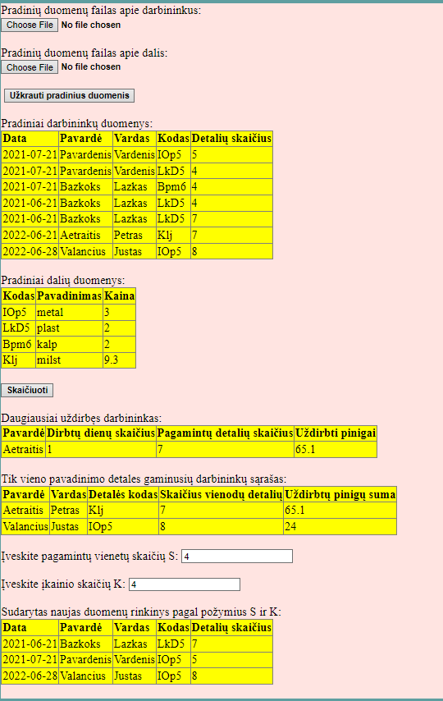

## Dėstytojo pastabos